**FDA Lab5**

**Q1.** Write a R program to enter any number and calculate its factorial.

**Q2.** Write a R program to print all Armstrong numbers between 1 to n.

**Q3.** Create a data frame given below

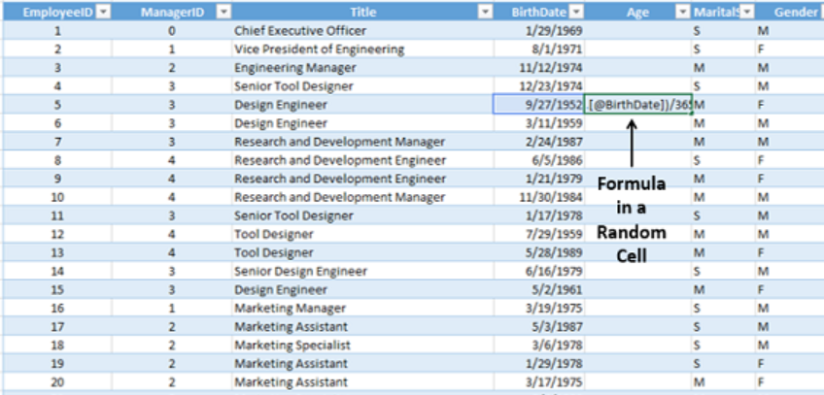

1. Append another column as **Age** by calculating the age from date of birth.
2. Calculate the mean, median, variance and SD of age
3. Display the details of Gender=Female(F)
4. Display the details of Gender= Male and who are married(M)
5. Count no of person having Title= Market Assistant and Marital status as Single(S)